Real Time AWS Management Console Login Alerts Using Telegram Bot

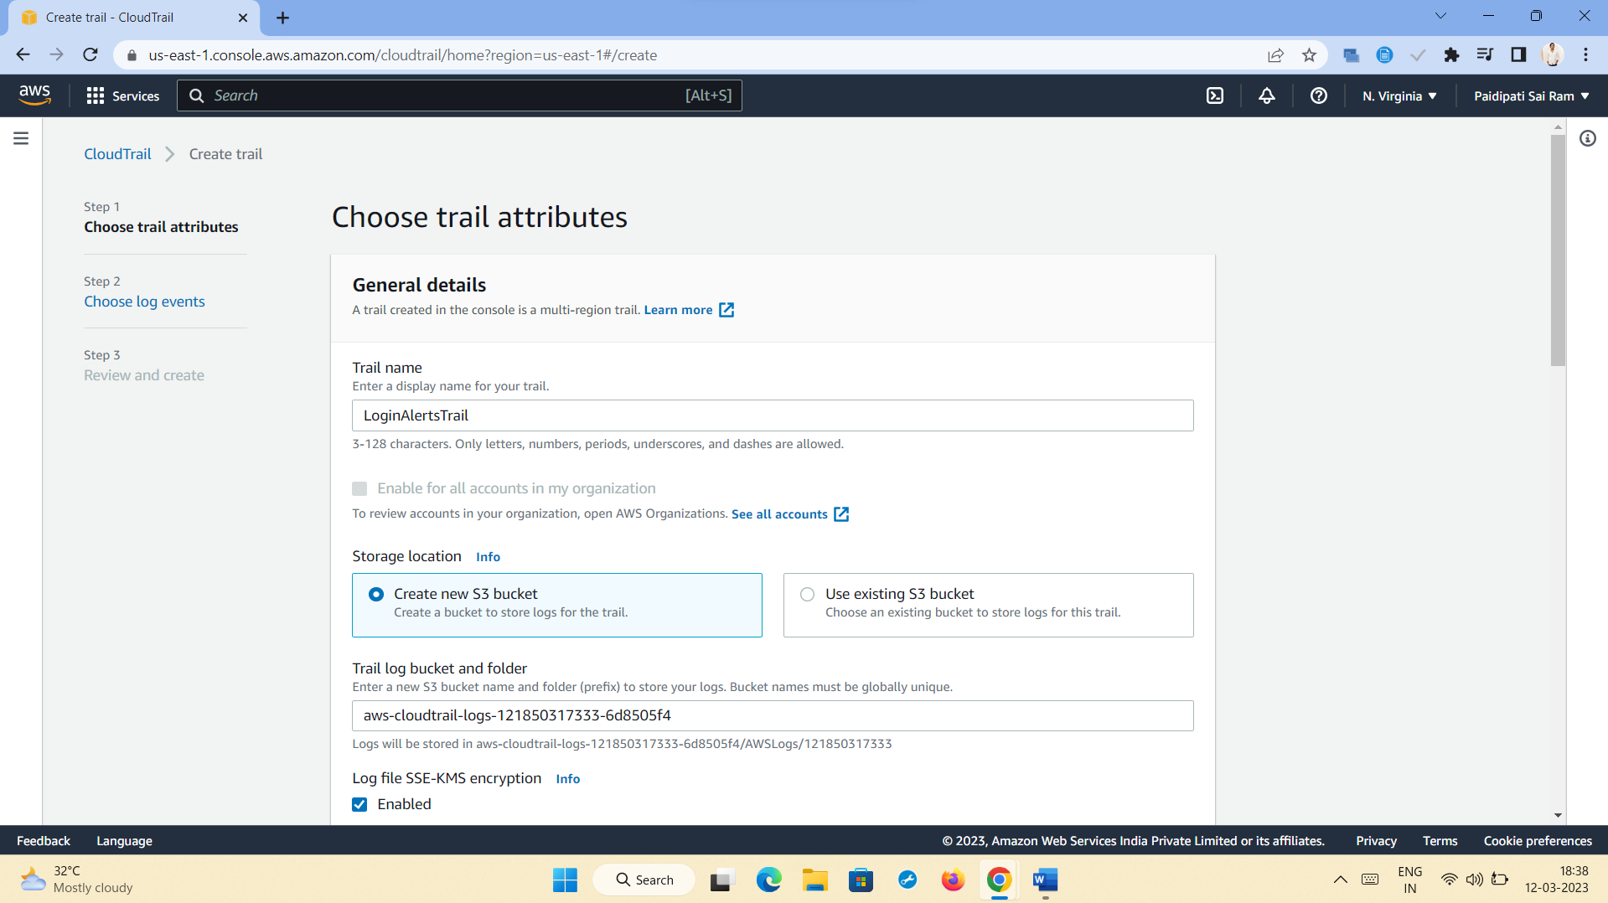

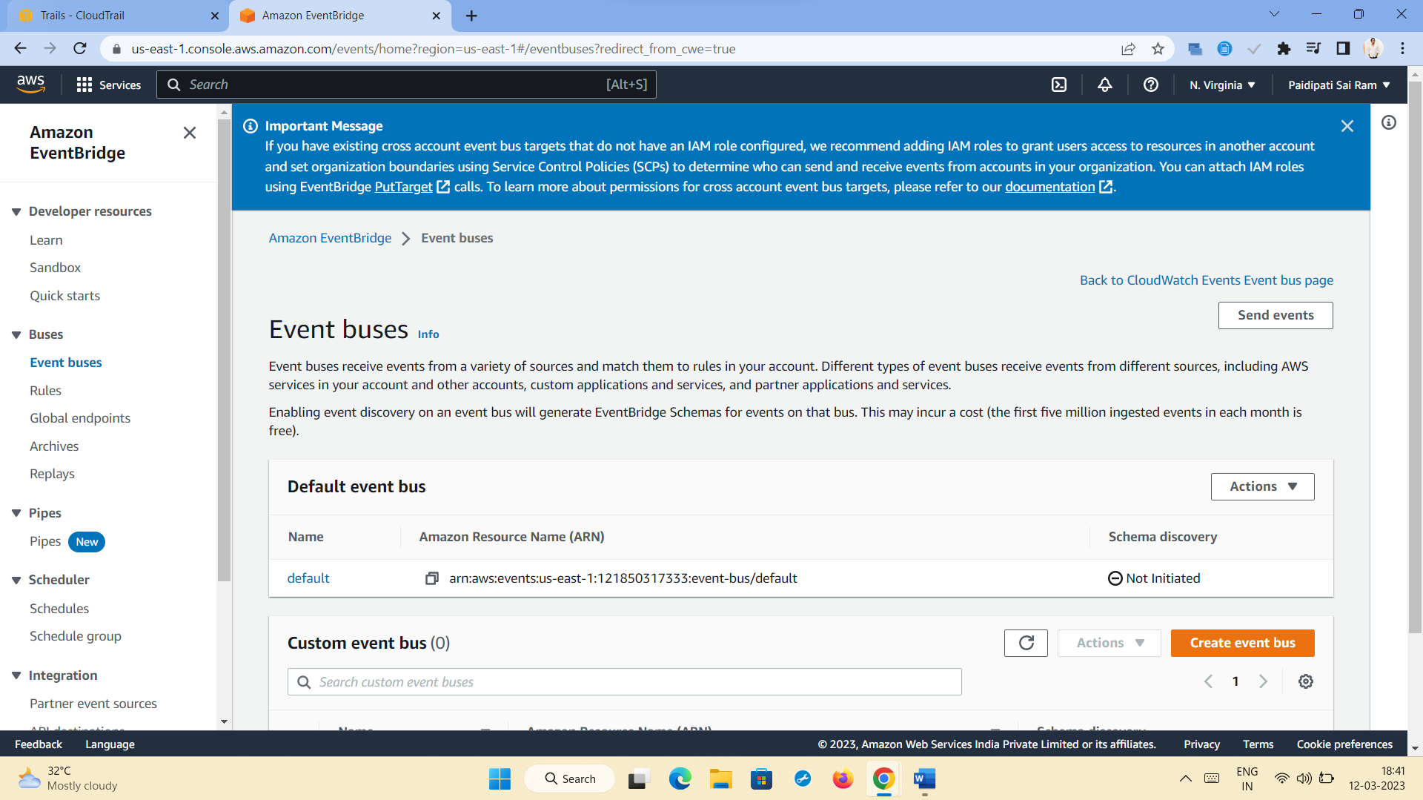 i+

6

